# Hero Competitions

## Database Usage

Write queries to match the output in the screenshots

1. Examine the create.sql file and create an [ERD](https://www.visual-paradigm.com/guide/data-modeling/what-is-entity-relationship-diagram/) of what you see.
2. Counting Rows

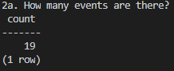

Your Query:

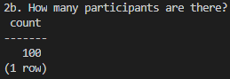

Your Query:

1. Event Details

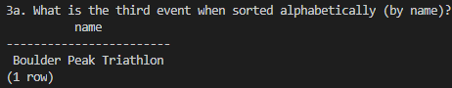

Your Query:

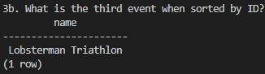

Your Query:

1. Event Participants

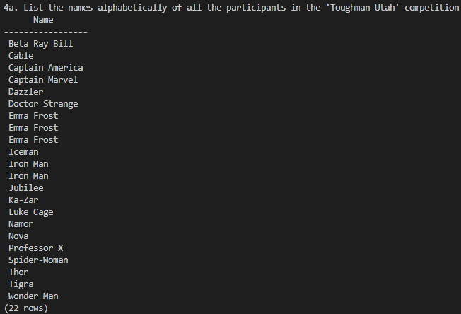

Your Query:

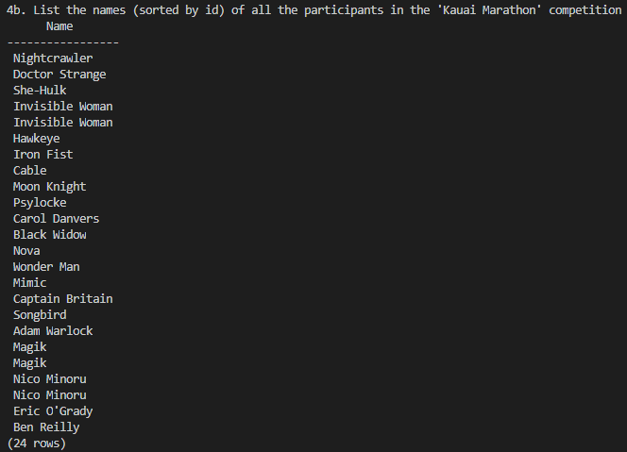

Your Query:

1. Participant Details
   1. How many competitions has Black Panther competed in?

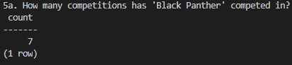

Your Query:

* 1. How can you verify that your count is correct?

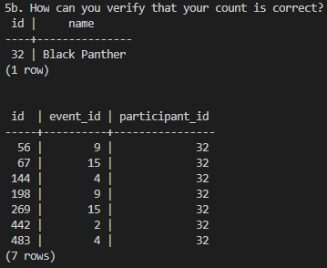

Your Queries:

* 1. Who has competed in the most competitions? How many have they competed in?

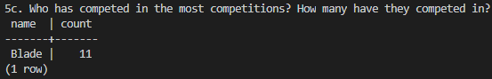

Your Query:

* 1. Who has competed in the least competitions? How many have they competed in?

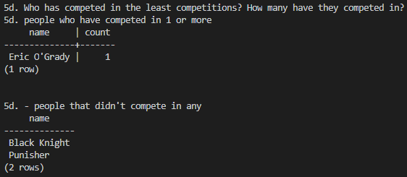

Your Query:

1. EXTRA QUERIES
   1. Is there anyone who has competed in the same competition twice?
   2. Which event had the most competitors?
   3. Which event had the least competitors?
   4. List all competitors that competed in the same event at least once
   5. How many people competed in swim competitions?
   6. What type of competition has the most overall competitors?

## PHP

1. Create a php page that will show all the names and rendered images of the events.